

Student Name……………………………………

MATHEMATICAL METHODS (CAS) UNITS 1 & 2

TRIAL EXAMINATION 2

2008

Reading Time: 15 minutes
Writing time: 2 hours

Instructions to students
This exam consists of Section 1 and Section 2.
Section 1 consists of 22 multiple-choice questions, which should be answered on the detachable answer sheet which can be found on page 25 of this exam.
Section 2 consists of 4 extended-answer questions.
Section 1 begins on page 2 of this exam and is worth 22 marks.
Section 2 begins on page 11 of this exam and is worth 58 marks.
There is a total of 80 marks available.
All questions in Section 1 and Section 2 should be answered.
Diagrams in this exam are not to scale except where otherwise stated.
Where more than one mark is allocated to a question, appropriate working must be shown.
Students may bring one bound reference into the exam.
Students may bring a CAS calculator into this exam.

This paper has been prepared independently of the Victorian Curriculum and Assessment Authority to provide additional exam preparation for students. The publication is in no way connected with or endorsed by the Victorian Curriculum and Assessment Authority.

© THE HEFFERNAN GROUP 2008
This Trial Exam is licensed on a non transferable basis to the purchasing school. It may be copied by the school which has purchased it. This license does not permit distribution or copying of this Trial Exam by any other party.
SECTION 1

Question 1
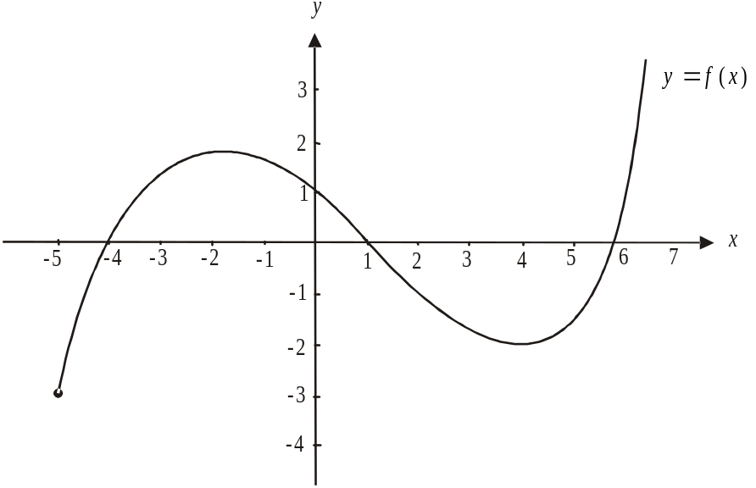

The minimum value of the function shown above is

- 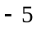
- 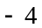
- 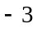
- 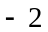
- 4

Question 2

The solution(s) of the equation is/are

- 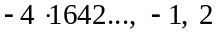
- 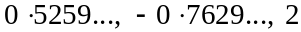

Question 3

If 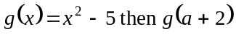 is given by

- 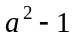
- 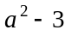
- 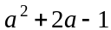
- 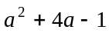
Question 4

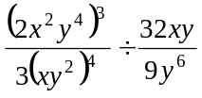 is equal to

- 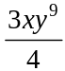
- 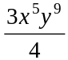
- 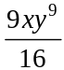
- 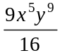
- 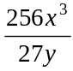

Question 5

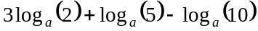 is equal to

- 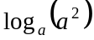
- 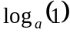
- 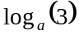
- 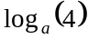
- 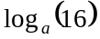

Question 6

Of the 47 Year 7 students surveyed, 24 said they intended trying out for the athletics team, 33 said that they intended trying out for the swimming team and 5 said they would try out for neither the swimming team nor the athletics team.
The number of Year 7 students who intended trying out for the swimming team only was

- 5
- 9
- 15
- 18
- 33

Question 7

The angle 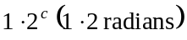, when expressed in degrees, is closest to

- 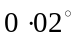
- 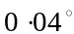
- 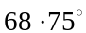
- 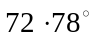
- 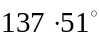
Question 8
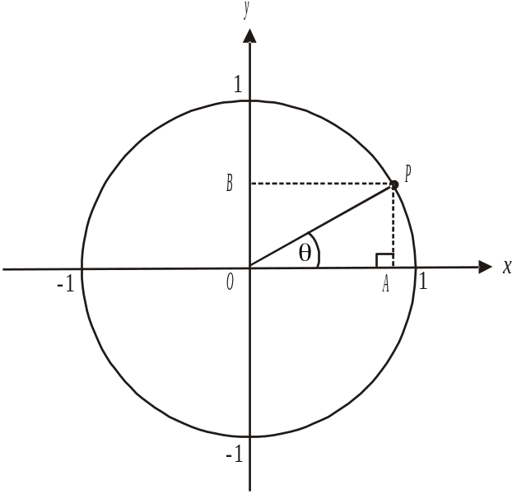

The diagram above shows a unit circle which the point P lies on. The angle made between OP and the positive branch of the x-axis is . Which one of the following is true?

- 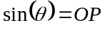
- 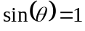
- 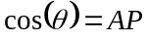
- 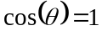
- 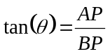

Question 9

A subcommittee of 5 people is to be selected from a committee of 12 people. The number of different subcommittees that can be formed is given by

- 5!
- 12!
- 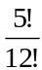
- 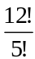
- 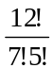

Question 10

The graph of the function f over the domain 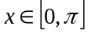 is shown below.

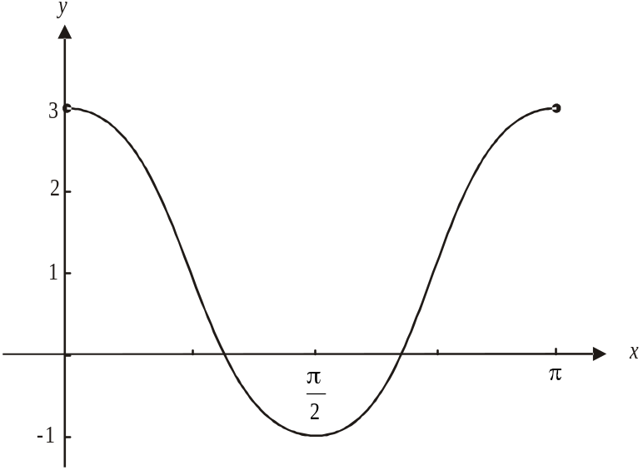

The rule for f could be

- 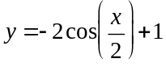
- 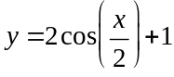
- 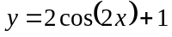
- 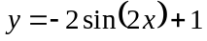
- 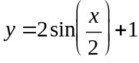

Question 11

If 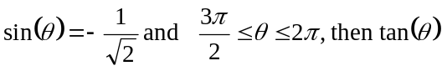 is equal to

- 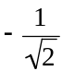
- – 1
- 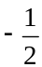
- 1
- 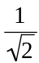
Question 12

The solutions to the equation 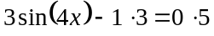 over the domain are closest to

Question 13

If 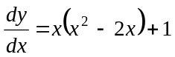 then y is equal to

- 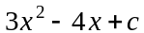
- 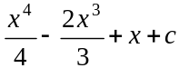
- 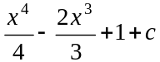
- 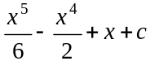
- 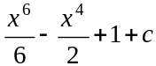

Question 14

If 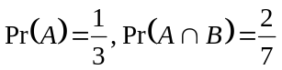 and A and B are independent events then 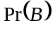 is equal to
- 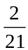
- 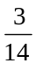
- 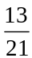

Question 15

Two boys and three girls are randomly arranged in a line outside the coordinators office. The probability that the two boys are standing next to one another is

- 0.2
- 0.3
- 0.4
- 0.5
- 0.6

Question 16

Which one of the following relations is not a function?

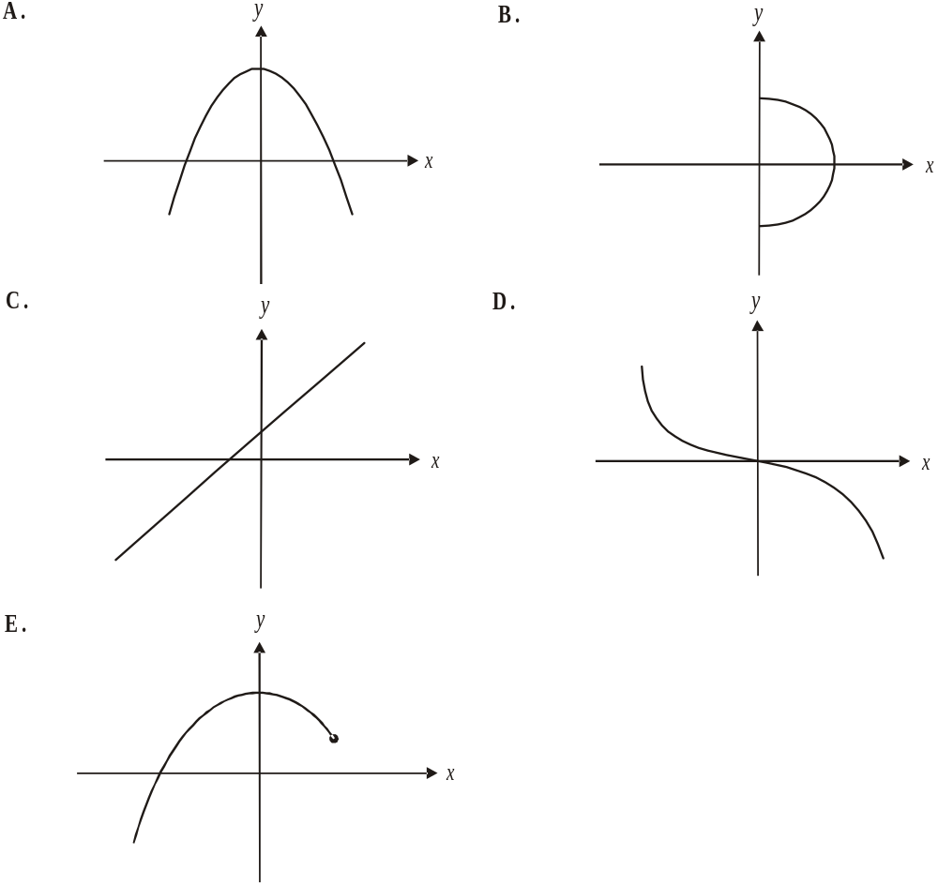

The information below relates to questions 17 and 18.

A particle starts from a fixed origin O and moves in a straight line with a velocity v (m/s) given by

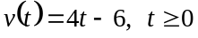

Question 17

The position of the particle 3 secs after it starts its motion is

- 12 metres to the left of O
- 6 metres to the left of O
- at O
- 4 metres to the right of O
- 6 metres to the right of O

Question 18

In the first 5 secs the particle has travelled a distance of

- 14m
- 20m
- 24.5m
- 29m
- 34m

Question 19

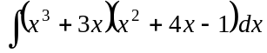 is equal to

- 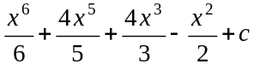
- 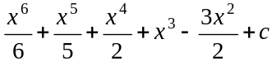
- 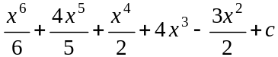
- 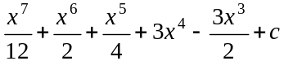
Question 20

Which one of the following expressions is not equal to 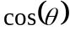

- 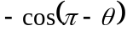
- 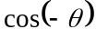
- 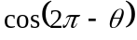
- 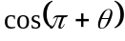
- 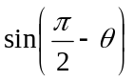

Question 21

Two fair dice are thrown simultaneously. The probability that the sum of the two numbers that come up is less than 4 is

- 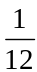

Question 22
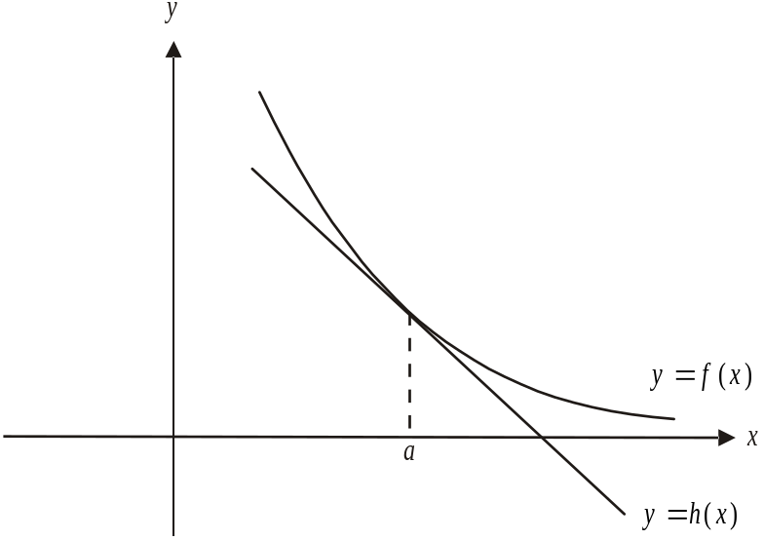

The graph of 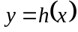 is a tangent to the graph of 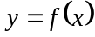 at the point where .
Which one of the following statements is not true?

- 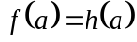
- 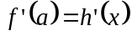
- 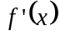 is a constant
- 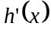 is a constant
- 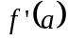 is a constant

SECTION 2

Question 1

A school stages a large musical production each year. As part of the cast in this year’s production there are three angels; one girl and two boys. At each of the two performances, one of these three is randomly chosen to complete a particular task on stage.

- Complete the tree diagram below by including the probabilities on each of the branches.

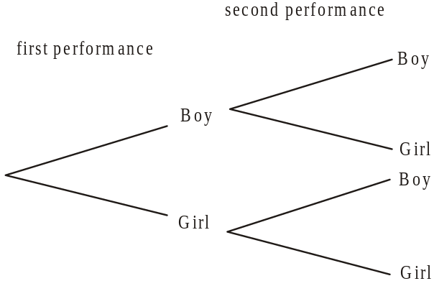

2 marks

- Over the two nights of the performance, what is the probability that a boy and a girl are randomly chosen?

1 mark

- What is the probability that a boy is chosen on the second night.

1 mark

- What is the probability that a girl is chosen on the second performance given that a boy had been chosen for the first performance?

1 mark
Students wanting to participate in the school musical production must attend one dance class each week during the first semester. Students can attend a dance class on a Tuesday lunchtime or on a Friday lunchtime.

The teacher in charge notices over time that

- 70% of students who attend Tuesday’s class will attend the following Tuesday
- 85% of students who attend Friday’s class will attend the following Friday.

- Enter this information into matrix T below, where T is the transition matrix.

this week
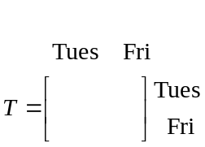
next week
2 marks

In the last week of term one, 37 students attended Tuesday’s class and 24 attended Friday’s class.

- Find 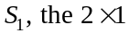 matrix that gives the number of students attending dance class on Tuesday and on Friday in week one of term two.

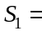
2 marks

- Find the number of students attending dance classes on Tuesday and on Friday in Week 10 of Term 2. Round off values where appropriate.

2 marks
Total 11 marks
Question 2

Water is stored in a toilet cistern and when the flush button is pressed, water leaves the cistern and flushes the toilet bowl. Fresh water is then pumped back in to re-fill the cistern.
The height, h, in cm, of water in the cistern t seconds after the flush button is pressed is given by the function
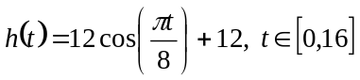

where represents the time at which the flush button is pressed.

- Write down

- the amplitude of the function

- the period of the function

  - On the set of axes below, sketch the graph of the function 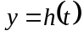. Show clearly on the graph any axes intercepts and the endpoints of the function.

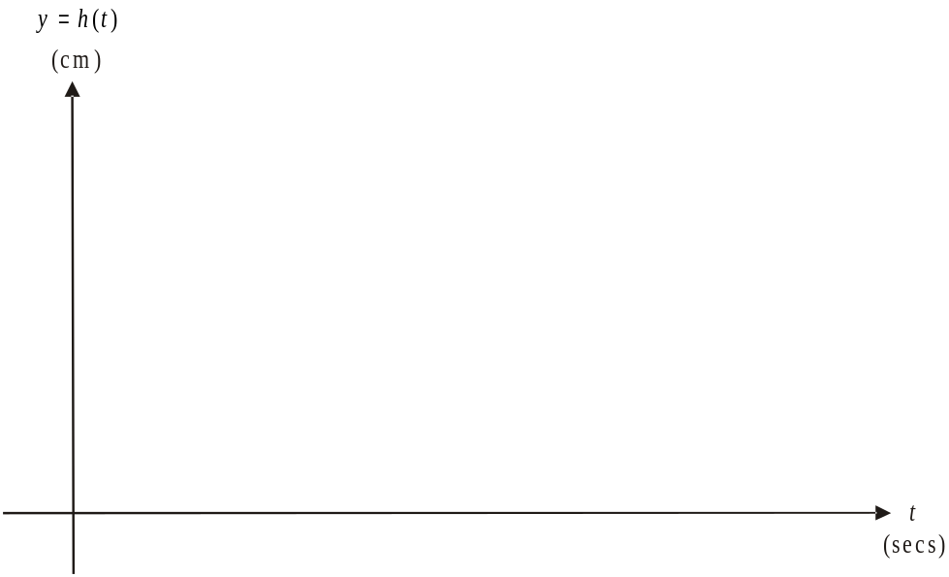

2 marks

  - When is the cistern completely empty of water?

1 mark

  - Between what times is fresh water being pumped back into the cistern?

1 mark

  - What is the maximum height that the water reaches in the cistern?

1 mark

- i. At what time did the height of the water first reach 18cm?

  - For what period of time during the period 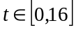, was the height of the water in the cistern 18cm or less?

Ted is three years old and at the same time as he presses the flush button on his toilet, his mother turns on the tap in the basin so that he can wash his hands. The height f, in cm, of the water in the basin at time t seconds after the tap is turned on is given by

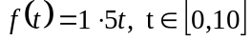

- i. Find the time(s) when the height of the water in the cistern is the same as the height of the water in the basin. Express your answer correct to 2 decimal places.

- Hence find when the height of the water in the cistern is greater than the height of the water in the basin?

Total 15 marks

Question 3

A bar stool has a circular base which is connected to the seat by a vertical metal pole as shown in the diagram below.
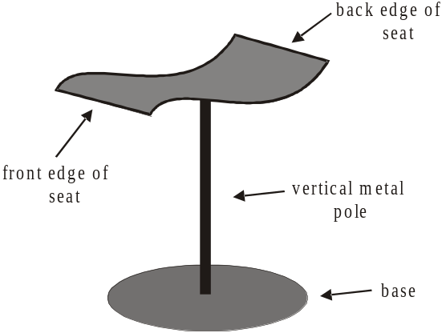

A cross-sectional view of the seat from one side can be modelled by the function f where
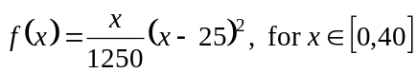 and where x represents the horizontal distance in cm from the corner of the front edge of the seat and the value of 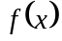 represents the distance vertically in cm from the front edge of the seat.
The graph of 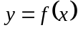 is shown below where the origin O 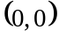, indicates the position of the front corner of the seat. The point B represents the back corner of the seat.

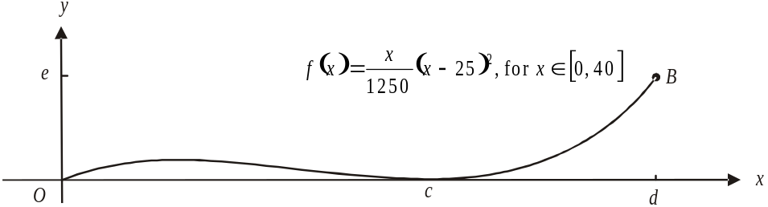

- Find the value of c.

1 mark

- Find the coordinates of the point B; that is find d and e.

2 marks

- What is the maximum height of the seat above the front edge?

1 mark
Darcy places a book on the bar stool so that some of it extends over the back edge of the seat. The cross-sectional view of this in relation to the x and y axes is shown on the diagram below.
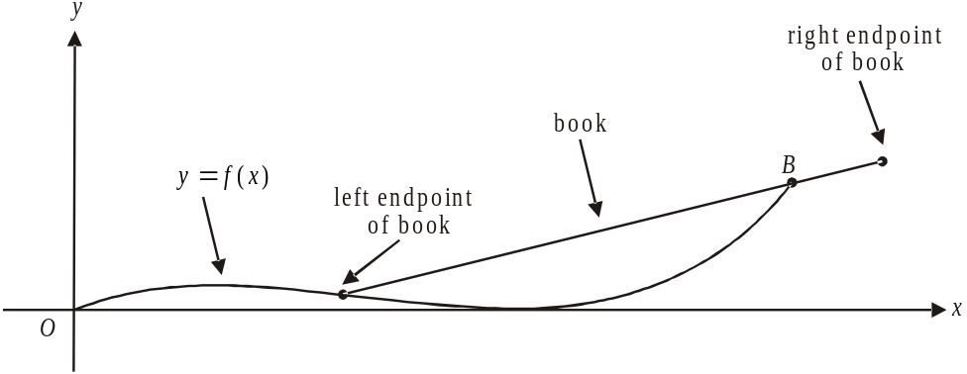

The left endpoint of the book rests at the point 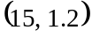 and the right endpoint of the book is positioned at the point 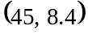.

- Show that the Cartesian equation of the cross-section of the book is given by

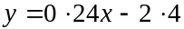

2 marks

- Write down the domain of the function described in part d.

1 mark

- Find the width of the book. Express your answer in cm correct to 2 decimal places.

1 mark
- Use calculus to find the values of x, correct to 2 decimal places, for which the gradient of the seat is the same as the gradient of the book as it rests on the seat.

3 marks

The manufacturer changes the design of the seat so that each point described by the function f is transformed according to the matrix

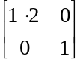

- Explain the type of transformation that this matrix represents.

1 mark

The depth of the seat (from front edge to back edge) on the original design was 40 cm.

- Using a matrix method, find the depth of the seat if the design is changed according to the given matrix.

2 marks

- If a new design was introduced so that points on the function f were to be reflected in the x-axis, write down the matrix that would describe this.

1 mark
Total 15 marks

Question 4

The main entrance to the performance arena of a circus is shown below.

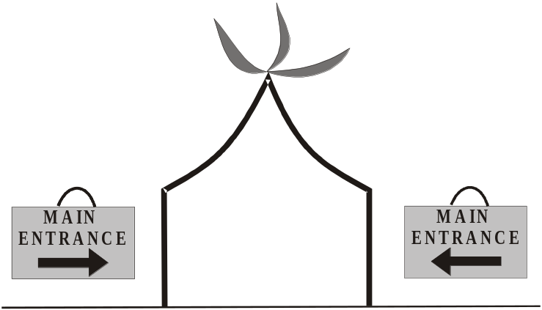

The height of the entrance above the ground can be described by the two functions

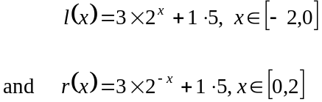

where l and r are symmetric about the line; the y-axis.

The graphs of l; the function to the left of the y-axis, and r; the function to the right of the y-axis are shown on the graph below.

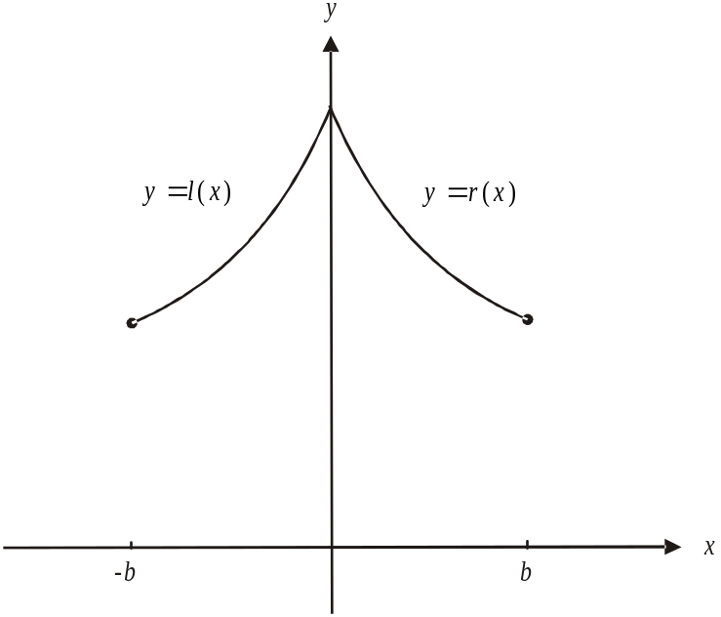

The x-axis represents the flat ground at the main entrance and the unit of measurement is the metre.

- Write down the value of b.

1 mark

- What is the width, in metres, of the main entrance at ground level?

1 mark

- i. What is the maximum height of the main entrance?

- What is the minimum height of the main entrance?

Whilst the circus is in town, Chinese New Year occurs and lanterns are to be hung across the top of the main entrance. One lantern is to be hung in the centre where and two lanterns are to be hung on either side at horizontal intervals of 0.8m.

- How far below the point from where the lantern in the centre is hung, will the point be from which the lantern closest to the side walls is hung? Express your answer correct to 2 decimal places.

2 marks

- The height of the main entrance is 3m or higher for 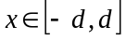. Find algebraically, the value of d.

2 marks

- A performer on stilts is 3.4m high. Explain where he should enter the main entrance without bumping into it and without having to bend down. Express any measurements in metres to 2 decimal places (ensuring that the performer will fit through).

2 marks

- If one of the acts is 1.4m wide and plans to enter the arena through the centre of the main entrance, what is the maximum height that it can have? Express your answer in metres to 2 decimal places (ensuring that the act will fit through).

2 marks
When the circus performers are rehearsing, the left hand side of the main entrance is completely covered and the right hand side is partly covered by a curtain as shown in the diagram below.
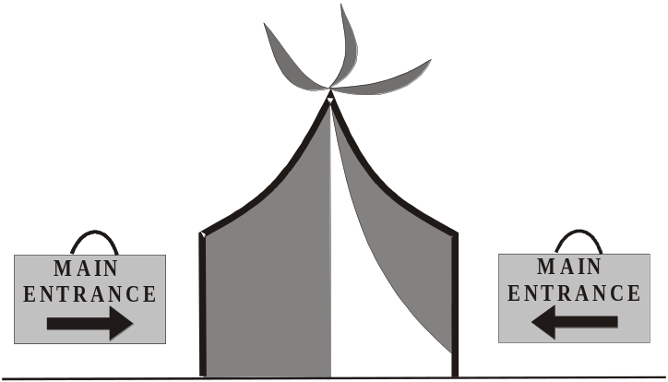

The height above the ground of the lower edge of the curtain can be defined by the function 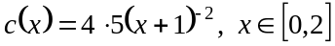 where the unit of measurement is the metre.

On the set of axes below the graph of 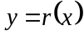 is shown.
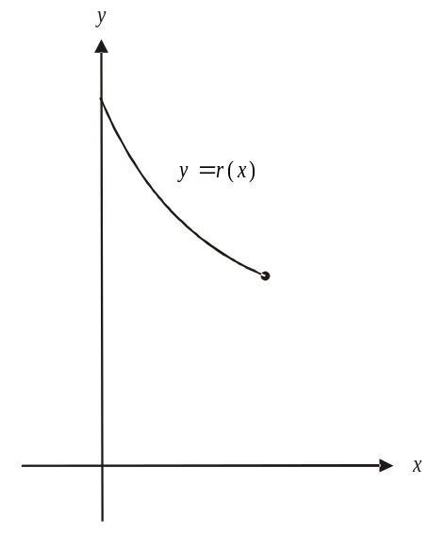

- On the same set of axes, sketch the graph of 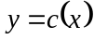. Clearly label any intercepts and endpoints.
2 marks
i. Show algebraically that the functions r and c intersect at a point which has an
x-coordinate of zero.

____________________________________________________________________

____________________________________________________________________

____________________________________________________________________

____________________________________________________________________
1 mark

A spinning wheel on a stand is wheeled into the arena as shown on the diagram below.
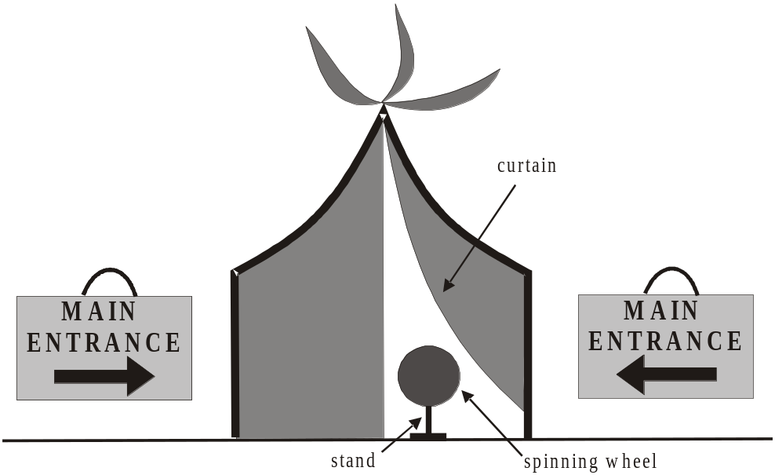

The spinning wheel is circular in shape with a radius of 0.4m. At the instant it is wheeled through the main entrance it’s centre is 0.72m vertically above the ground and 1m horizontally from the edge of the curtain which is described by the function c from part h.

- Write down the Cartesian equation that represents the outer edge of the spinning wheel.

2 marks
Total 17 marks

